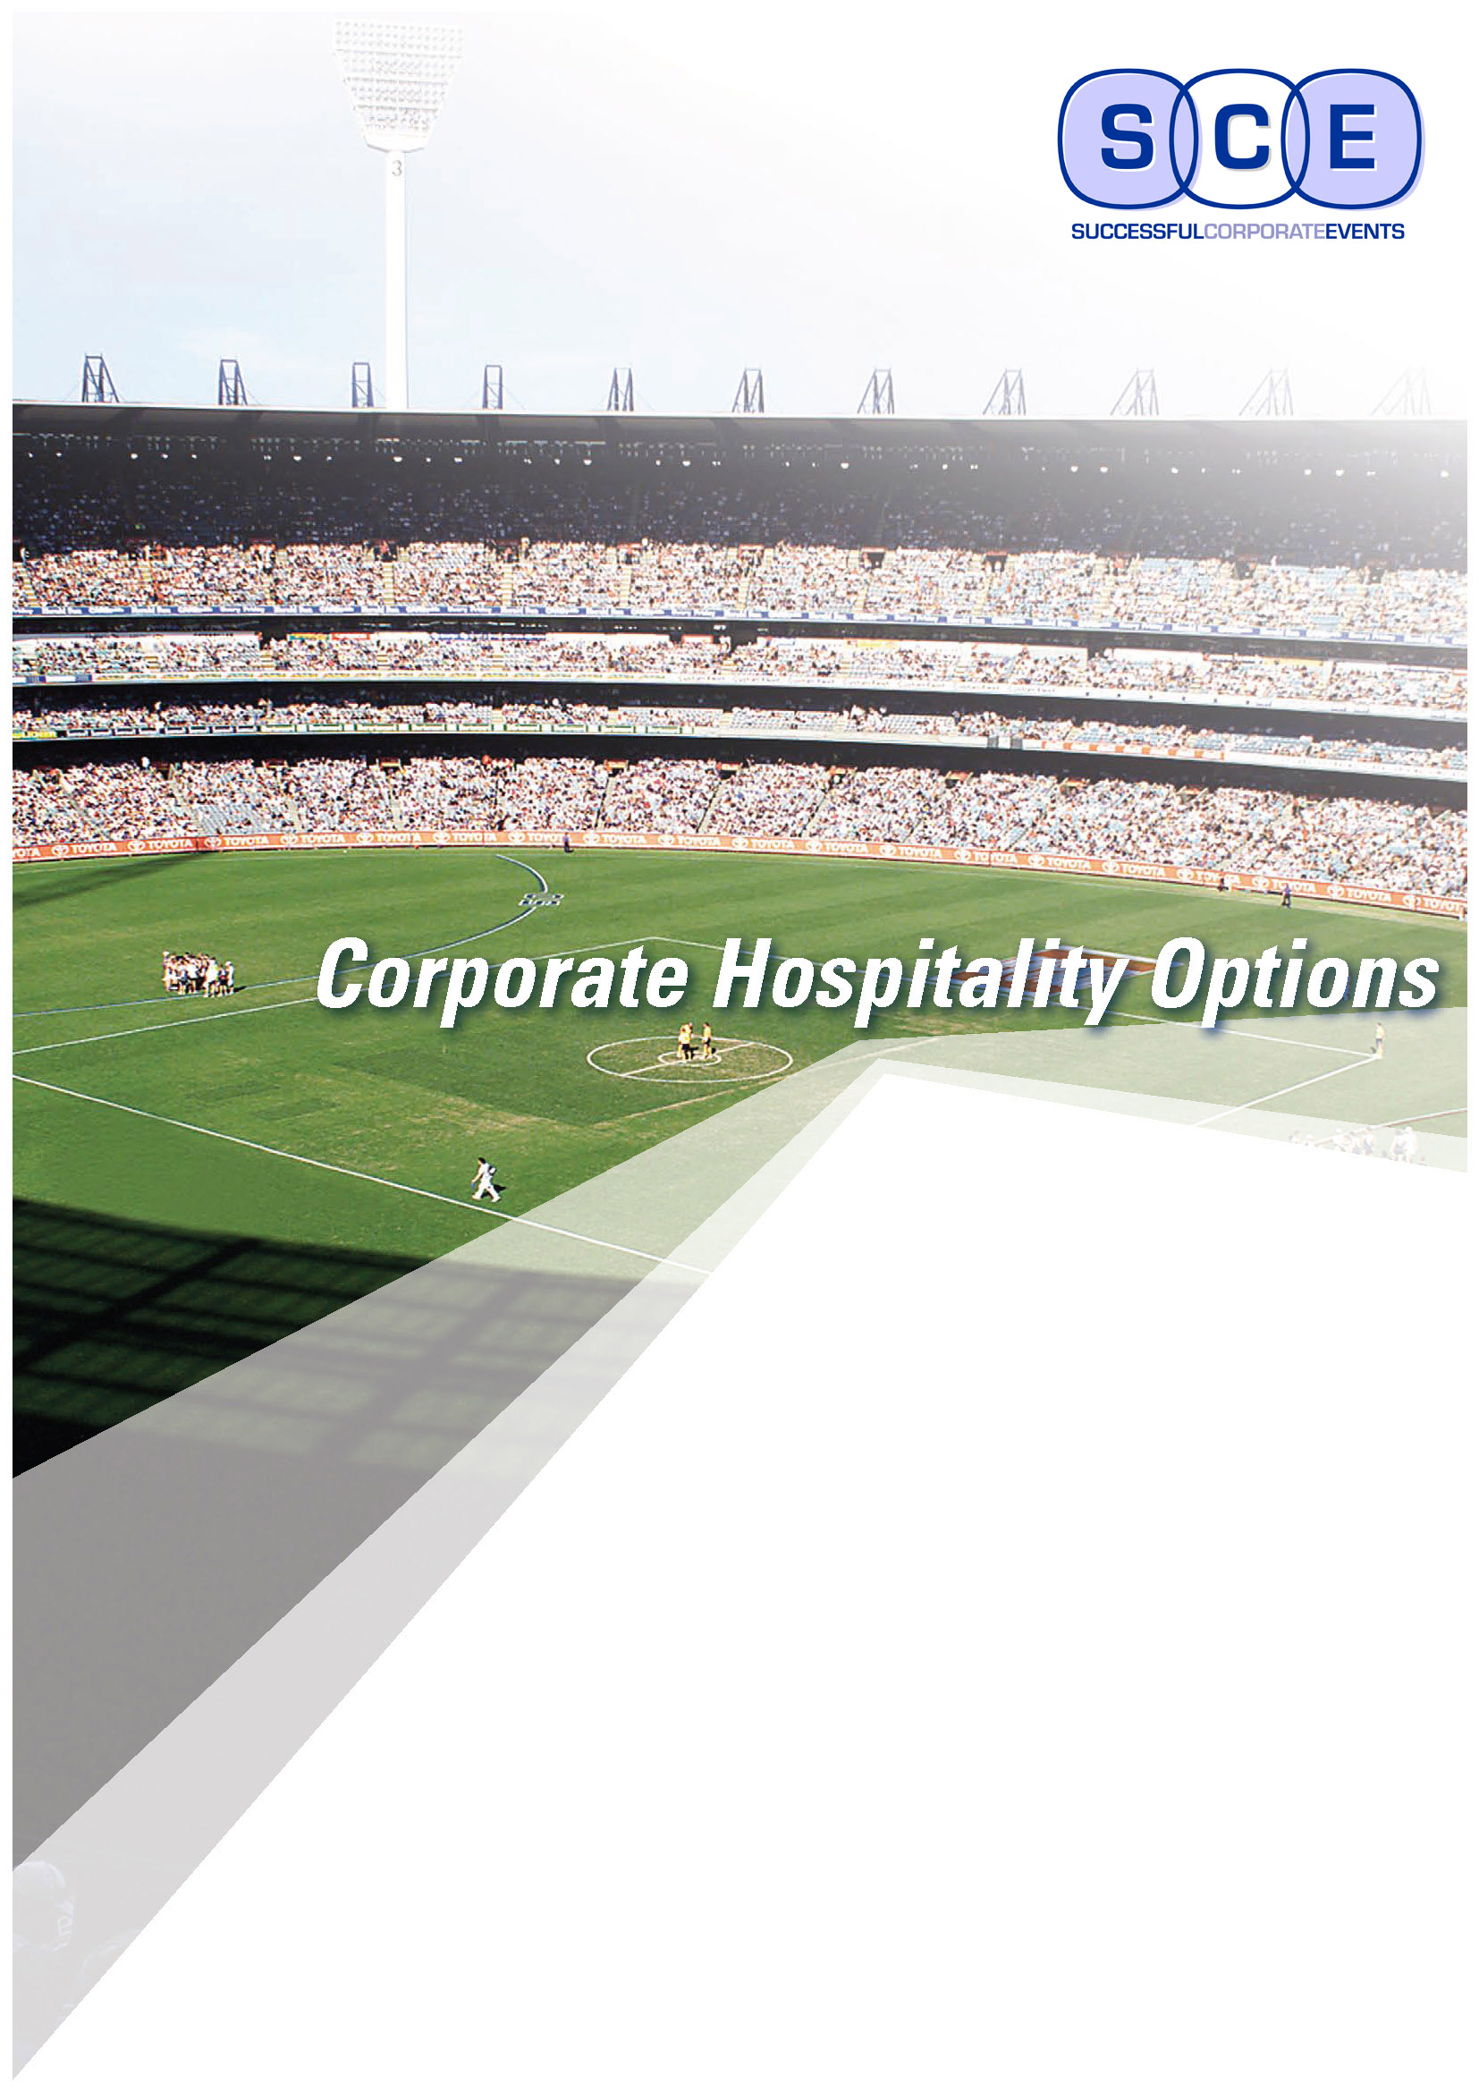
AFL Season 2017

When it comes to corporate hospitality
in Melbourne...
It’s no secret that Melbourne is the sports and entertainment capital of Australia.

At Successful Corporate Events, our passion is Aussie Rules so we specialize in AFL corporate packages at both the iconic Melbourne Cricket Ground (MCG) and Etihad Stadium for all AFL games.

Corporate hospitality is a great way to build strong, trusting relationships with existing and prospective clients, leveraging new business opportunities and growth.
With AFL, in Melbourne alone, you have almost 100 games to choose from over a six month period to entertain your clients and build strong business networks.

With a choice of casual or corporate dining & premium seating to exclusive corporate boxes we will work closely with you to customize a package that is best suited to your business, your budget and of course your valued clients.
“Corporate entertainment is not just an experience, it’s an investment”

Corporate Suite/Box
If you are looking for the perfect setting for serious networking or socialising with your guests, then the exclusivity of a corporate suite (commonly referred to as a Corporate Box) offers you the optimum balance
of comfort and style. With seating room for 12 to 20 guests, you and your clients will be indulged with the finest of catering by dedicated and friendly staff in modern facilities at the MCG or Etihad Stadium.
Package Inclusions:
First class viewing behind sliding glass in your own private suite
Choice of deluxe buffet or sit-down meal
Premium beer, wine and soft drink served prior to, during and after the game
Complimentary car park 2 or 4 passes
Complimentary AFL Records
Price: From $450 to $700 per person (price is dependant of the teams playing and when)

Premium or Casual Dining
AFL Premiership Club at the MCG
The AFL Premiership Club dining is one of the best dining functions available at the MCG
It is also without doubt the most cost effect option, certainly a great alternative to a Corporate Suite.
On level 2 of the newly revamped Great Southern stand the dining room boasts views of the ground,
with premium seating nearby outside the front of the dining room.
Add to this a delicious a la carte menu with fine beverages throughout the event served in style in a relaxed environment, and you and your guests are in for a memorable and enjoyable experience.
Package Inclusions:
Entry to the MCG and dining room which overlooks the ground
Premium reserved seating, level 2 Centre Wing of the Southern Stand
Three course a-la-carte lunch/dinner (choice of 3 entrees and 4 mains) – Black tie service
Beverage package includes beer, wine and soft drink served throughout the event
Afternoon tea/supper at half time and further post match drinks and savories
Complimentary AFL Record for each guest
High profile MC and Guest Speaker (at AFL nominated games)
Dress code: Dress denim and collared shirt for Gentlemen & Ladies smart casual
Price: From $295 (eg. standard game) $360 Friday night to $495 per person (Blockbuster game)
Other Corporate Dining Packages with Premium reserved seating options are available at both
the MCG and Etihad Stadium.

Casual Dining Package with
Premium Seating Ticket
@ Etihad Stadium or the MCG
Want a more cost effective option and don’t mind a Saturday afternoon or Sunday game
that is not classed as a ‘blockbuster game’?
Then this package is great for those who want to take their clients, staff or friends to the footy in jeans,
and enjoy a nice sit-down meal with beverages served throughout.
Price: From $280-$300 per person

Premium Seating Tickets
@ Etihad Stadium or the MCG

Premium Seating tickets are a great way to thank your clients or use as staff incentives rather than having to host the game yourself and pay additional for dining.
Once at the MCG or Etihad Stadium, they will have access to exclusive bars to purchase their drinks.
Price from $80 to $150 per person

For all AFL corporate hospitality enquiries, please contact
Merryn Gilbert Email: mgilbert@scevents.com.au
Mobile: 0429 965 900
Please note: all prices are a guide and are dependent on the game, package inclusions and availability.
We are happy to offer you a quote and to negotiate prices

